Chapter 3
Hello, World!
In this chapter, we’ll get down-and-dirty and write a real working EJB component. Our stateless session bean will be responsible for the mighty task of returning the string “Hello, World!” to the client. We'll see how to write each of the files that make up this bean, and how to access it from clients.
This chapter is great for you if you want to discover how to get up and running with EJB quickly. While this may not be the most functional demonstration of the power of EJB, this is a great example for illustrating the basics of EJB programming, and it is a useful template for building more complex beans. This will give you the necessary foundation to then understand the later chapters on entity beans, session beans, and message-driven beans.
How to Develop an EJB Component
When building an EJB component, the following is a typical order of operations:
- Write the .java files that compose your bean: the component interfaces, the home interfaces, the enterprise bean class file, and any helper classes you might need.
- Write the deployment descriptor.
- Compile the .java files from step 1 into .class files.
- Using the jar utility, create an ejb-jar file containing the deployment descriptor and .class files.
- Deploy the ejb-jar file into your container in a vendor-specific manner, perhaps by running a vendor-specific tool or perhaps by coping your ejb-jar file into a folder where your container looks to load ejb-jar files.
- Configure your EJB server so that it is properly configured to host your ejb-jar file. You might tune things such as database connections, thread pools, and so-on. This step is vendor-specific and might be done through a web-based console, or editing a configuration file.
- Start your EJB container, and confirm that it has loaded your ejb-jar file.
- Optionally, write a standalone test client .java file. Compile that test client into a .class file. Run the test client from the command line and have it exercise your bean's APIs.
We will apply the above process to our Hello World example. The complete build scripts are available with the book's accompanying source code.
The object model for our Hello World example is shown in Figure X.X.
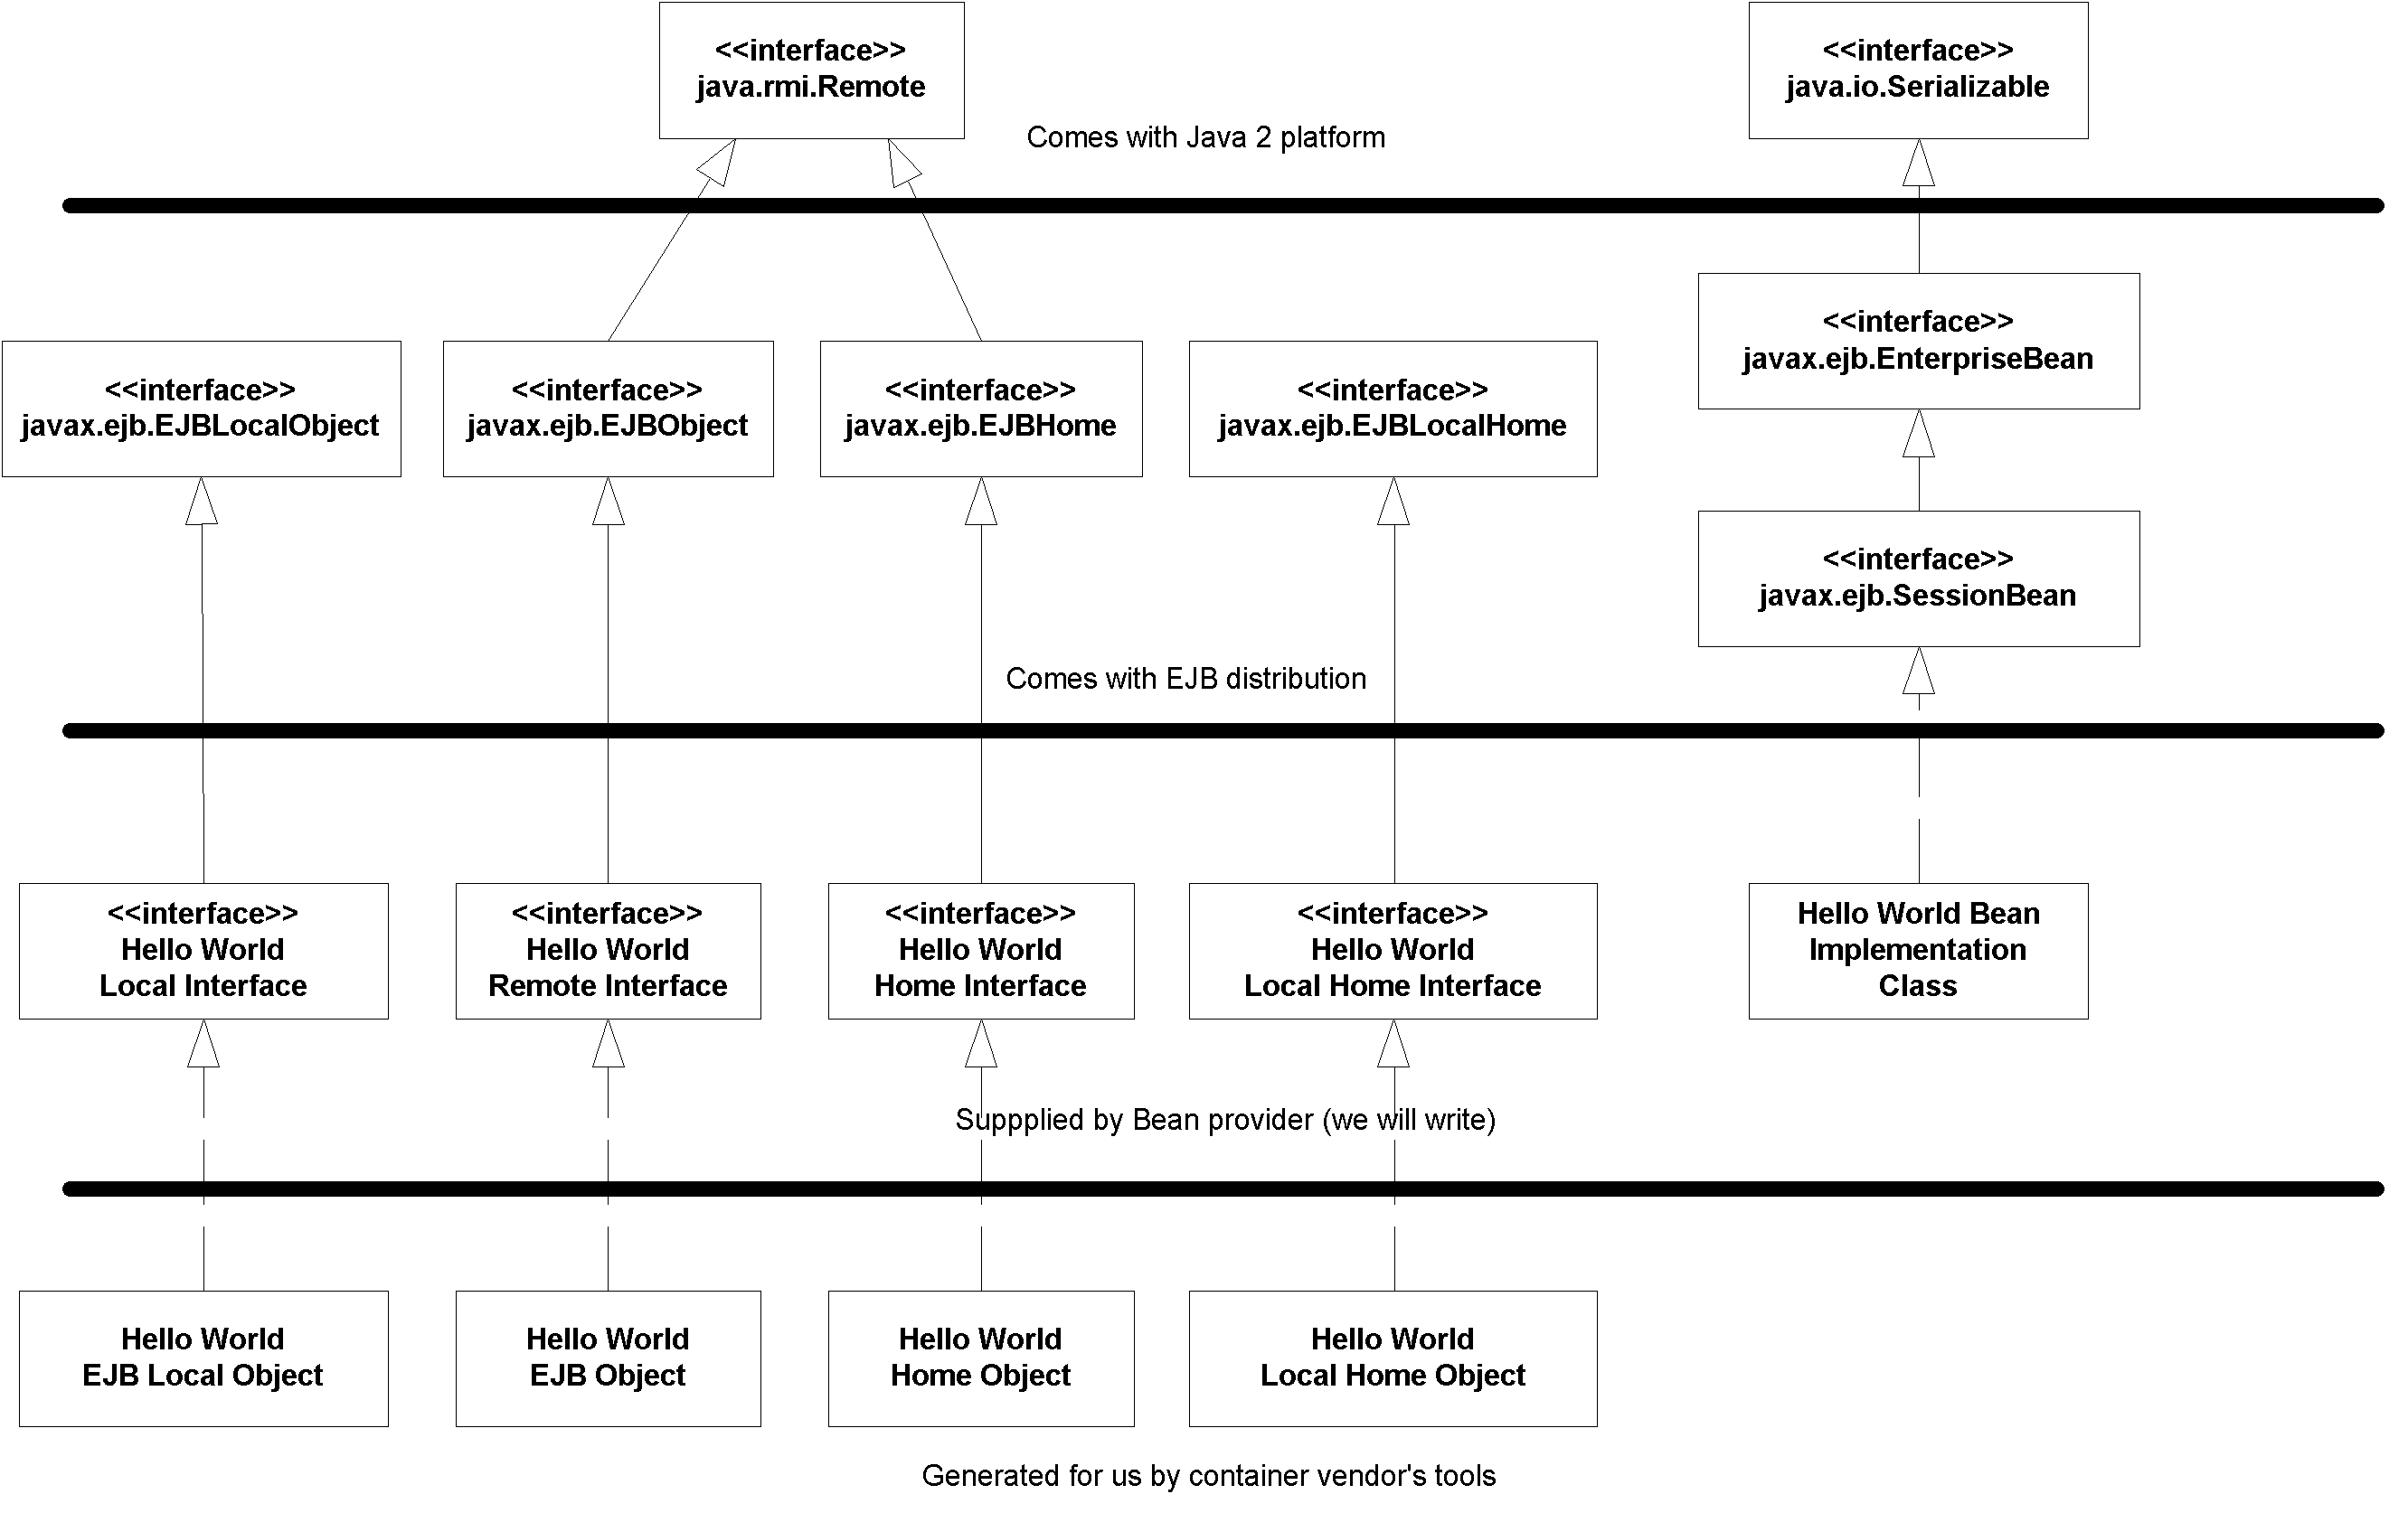
Figure X.X Our Hello World Object Model
The Remote Interface
First, let's code up the remote interface. The remote interface duplicates every business method that our beans expose. The code is shown in Source 3.X.
package examples;

/**
* This is the HelloBean remote interface.
*
* This interface is what clients operate on when
* they interact with EJB objects. The container
* vendor will implement this interface; the
* implemented object is the EJB object, which
* delegates invocations to the actual bean.
*/
public interface Hello extends javax.ejb.EJBObject
{

/**
* The one method - hello - returns a greeting to the client.
*/
public String hello() throws java.rmi.RemoteException;
}
Source 3.X Hello.java.
Things to notice about our remote interface include the following:
- We extend javax.ejb.EJBObject. This means the container-generated EJB object, which implements the remote interface, will contain every method that the javax.ejb.EJBObject interface defines. This includes a method to compare two EJB objects, a method to remove an EJB object, and so on.
- We have one business method--hello()--which returns the String “Hello, World!” back to the client. We’ll need to implement this method in our enterprise bean class. Because the remote interface is an RMI-IIOP remote interface (it extends java.rmi.Remote), it must throw a remote exception. This is really the only difference between the remote interface’s hello() signature and our bean’s hello() signature. The exception indicates a networking or other critical problem.
The Local Interface
Local clients will use our local interface, rather than remote interface, to call our beans' methods. It's shown in Source X.X.
package examples;

/**
* This is the HelloBean local interface.
*
* This interface is what local clients operate
* on when they interact with EJB local objects.
* The container vendor will implement this
* interface; the implemented object is the
* EJB local object, which delegates invocations
* to the actual bean.
*/
public interface HelloLocal extends javax.ejb.EJBLocalObject
{

/**
* The one method - hello - returns a greeting to the client.
*/
public String hello();
}
Source X.X HelloLocal.java.
As you can see, there are trivial differences between the local interface and the remote interface.
The Home Interface
Next, let's put together the home interface. The home interface has methods to create and destroy EJB objects. The implementation of the home interface is the home object, which is generated by the container tools.
The code for our home interface is shown in Source 3.X.
package examples;

/**
* This is the home interface for HelloBean. This interface
* is implemented by the EJB Server's tools - the
* implemented object is called the Home Object, and serves
* as a factory for EJB Objects.
*
* One create() method is in this Home Interface, which
* corresponds to the ejbCreate() method in HelloBean.
*/
public interface HelloHome extends javax.ejb.EJBHome
{

/*
* This method creates the EJB Object.
*
* @return The newly created EJB Object.
*/
Hello create() throws java.rmi.RemoteException,
javax.ejb.CreateException;
}
Source 3.X HelloHome.java.
Notice the following about our home interface:
- The single create() is a factory method that clients use to get a reference to an EJB object. The create() method is also used to initialize a bean.
- The create() method throws a java.rmi.RemoteException and javax.ejb.CreateException. Remote exceptions are necessary side effects of RMI-IIOP because the home object is a networked RMI-IIOP remote object. The CreateException is also required in all create() methods. We explain this further in the following sidebar.
- Our home interface extends javax.ejb.EJBHome. This is required for all home interfaces. EJBHome defines a way to destroy an EJB object, so we don’t need to write that method signature.
Exceptions and EJB
Every networked object in EJB conforms to the RMI-IIOP standard and must throw a remote exception. Thus, every method in an EJB object and home object (such as our hello() method) must throw a remote exception. When such an exception is thrown, it indicates a special error condition--that a network failure, machine failure, or other catastrophic failure occurred.
But how can your beans throw exceptions that indicate regular, run-of-the-mill problems, such as bad parameters passed to a business method? EJB comes with some built-in exceptions to handle this, and it also allows you to define your own exception types.
More formally, EJB defines the following exception types:
1. A system-level exception is a serious error that involves some critical failure, such as a database malfunction.
2. An application-level exception is a normal, run-of-the-mill exception, such as an indication of bad parameters to a method or a warning of an insufficient bank account balance to make a withdrawal. For example, in our “Hello, World!” home interface, we throw a standard javax.ejb.CreateException from home interface’s create() method. This is an example of a required application-level exception, indicating that some ordinary problem occurred during bean initialization.
Why must we separate the concepts of system-level and application-level exceptions? The chief reason is that system-level exceptions are handled quite differently from application-level exceptions.
For example, system-level exceptions are not necessarily thrown back to the client. Remember that EJB objects--the container-generated wrappers for beans--are middlemen between a bean’s client and the bean itself. EJB objects have the ability to intercept any exceptions that beans may throw. This allows EJB objects to pick and choose which exceptions the client should see. In some cases, if a bean fails, it may be possible to salvage the client’s invocation and redirect it to another bean. This is known as transparent fail-over--a quality of service that some EJB container/server vendors provide. This is a very easy service to provide for stateless beans because there is no lost state when a bean crashes. Some high-end EJB products even provide transparent fail-over for stateful beans by routinely checkpointing the stateful bean’s conversational state. In case of a critical, unrecoverable problem, your EJB container may support professional monitoring systems, alerting a system administrator in the event of a catastrophic error.
By way of comparison, application-level exceptions should always be thrown back to the client. Application-level exceptions indicate a routine problem, and the exception itself is valuable data that the client needs. For example, we could notify a client that there are insufficient funds in a bank account by throwing an application-level exception. The client would always want to know about this because it is an application-level problem, not a systems-level problem.
Besides correctly routing system-level and application-level exceptions, the EJB object is responsible for catching all unchecked exceptions (flavors of java.lang.RuntimeException) that your bean may throw, such as a NullPointer exception. These are typically not caught by code. Exceptions that are unchecked in the bean could leave the bean in an abnormal state because the bean is not expecting to handle such an exception. Under this kind of scenario, the EJB container intercepts the exception and can perform some action, such as throwing the exception back to the client as a remote exception. It also will probably stop using that bean because the bean is in an undefined state.
The following two rules of thumb should help you with exceptions:
1. Application-level exceptions are always thrown back to the client. This includes any exception the bean defines. It also includes the javax.ejb.CreateException for creating beans (and the javax.ejb.FindException for entity beans, which we’ll see in Chapter X).
2. When system-level exceptions occur, the EJB container can do anything it wants to: page a system administrator with an alert, send an e-mail to a third party, or throw the exception back to the client. Your bean can throw a system-level exception as either an RMI-IIOP remote exception or an unchecked RuntimeException. If the exception is thrown to the client, it is always thrown as a remote exception or a subclass of it.
Exceptions also have an impact on transactions. We’ll learn more about this effect in Chapter X
The Local Home Interface
Our local home interface, the higher performing home interface used by local clients, is in Source X.X.
package examples;

/**
* This is the local home interface for HelloBean.
* This interface is implemented by the EJB Server's
* tools - the implemented object is called the
* local home object, and serves as a factory for
* EJB local objects.
*/
public interface HelloLocalHome extends javax.ejb.EJBLocalHome
{

/*
* This method creates the EJB Object.
*
* @return The newly created EJB Object.
*/
HelloLocal create() throws javax.ejb.CreateException;
}
Source X.X HelloLocalHome.java.
The differences between the remote interface and local interface are:
- The local home interface extends EJBLocalHome rather than EJBHome. The EJBLocalHome interface does not extend java.rmi.Remote. This means that the generated implementation will not be a remote object.
- The local home interface does not throw RemoteExceptions.
What happens during create() and remove()
As we've learned, the container creates and destroys your beans, rather than clients. But if the container is responsible for bean life cycle, then why does the home interface and local home interface specify create() and remove() methods? What you must remember is that these methods are for creating and destroying EJB objects. This may not correspond to the actual creation and destruction of beans. The client shouldn’t care whether the actual bean is created or destroyed--all the client code cares about is that the client has an EJB object to invoke. The fact that beans are pooled and reused behind the EJB object is irrelevant.
So, when debugging your EJB applications, don’t be alarmed if your bean isn’t being created or destroyed when you call create() or remove() on the home object or local home object. Depending on your container’s policy, your beans may be pooled and reused, with the container creating and destroying at will.
The Bean Class
Now let’s look at the bean class itself. The code is shown in Source 3.X.
package examples;

/**
* Demonstration stateless session bean.
*/
public class HelloBean implements javax.ejb.SessionBean {

private SessionContext ctx;

//
// EJB-required methods
//
public void ejbCreate() {
System.out.println("ejbCreate()");
}

public void ejbRemove() {
System.out.println("ejbRemove()");
}

public void ejbActivate() {
System.out.println("ejbActivate()");
}

public void ejbPassivate() {
System.out.println("ejbPassivate()");
}

public void setSessionContext(javax.ejb.SessionContext ctx) {
this.ctx = ctx;
}

//
// Business methods
//
public String hello() {
System.out.println("hello()");
return "Hello, World!";
}
}
Source 3.X HelloBean.java
This is about the most basic bean class you can have. Notice the following:
- Our bean implements the javax.ejb.SessionBean interface, which makes it a session bean. This interface defines a few required methods that you must fill in. The container uses these 'management methods' to interact with the bean, calling them periodically to alert the bean to important events. For example, the container will alert the bean when it is being initialized and when it is being destroyed. These callbacks are not intended for client use, so you will never call them directly--only your EJB container will. We’ll learn about the specifics of these management methods in the pages to come.
- The bean has an ejbCreate() method which matches the home object's create() method, and takes no parameters.
- We have one business method, hello(). It returns "Hello, World!" back up to the client.
- The ejbActivate() and ejbPassivate() methods do not apply to stateless session beans, and so we leave these methods empty. We’ll see what these methods mean and what to use them for later in this chapter.
- When we destroy the bean, there’s nothing to clean up, so we have a very simple ejbRemove() method.
We also have a method called setSessionContext(). This method is explained in the following sidebar.
EJBContexts: Your Gateway to the Container
Since your enterprise beans live in a managed container, the container is free to call your EJB component's methods at its leisure. But what if your bean needs to query the container for information about its current status? For example, inside your bean, you may want to access the security credentials of the user currently calling your bean's method.
The container houses all of this information in one object, called an EJB context object. An EJB context object is your gateway to the container. EJB contexts are physical parts containers, and can be accessed from within your beans. Thus, a context represents a way for beans to perform callbacks to the container. These callbacks help beans both ascertain their current status and modify their current status. This is shown in Figure X.X@@@COMP: FC within SBT@@@
Figure X.X EJB Contexts
The motivation behind a context is to encapsulate the bean’s domain in one compact object. Note that a bean's status may change over the bean's life cycle, and thus this context object can dynamically change over time as well. At runtime, the container is responsible for changing the context to reflect any status changes, such as the bean becoming involved in a new transaction.
Here is what the javax.ejb.EJBContext interface looks like (thrown exceptions omitted):@@@COMP: CODE within SBT@@@
public interface javax.ejb.EJBContext
{
/*
* Call these from within your bean to access
* your own home object or local home object.
*
* You can use them to create, destroy, or
* find EJB objects and EJB local objects
* of your own bean class type.
*/
public javax.ejb.EJBHome getEJBHome();
public javax.ejb.EJBLocalHome getEJBLocalHome();

/*
* These are transaction methods - see Chapter X
*/
public boolean getRollbackOnly();
public void setRollbackOnly();
public javax.transaction.UserTransaction getUserTransaction();

/*
* These are security methods - see Chapter X
*/
public boolean isCallerInRole(java.lang.String);
public java.security.Principal getCallerPrincipal();
}
An EJB context contains callbacks useful for session beans, entity beans, and message-driven beans. In comparison, a session context, entity context, and message-driven context are specific EJB contexts used only for session beans, entity beans, and message-driven beans.
The container associates your bean with a context by calling setSessionContext, setEntityContext, or setMessageDrivenContext depending on your bean type. When you define each of these methods, you should store the context away in a member variable so the context can be queried later, as shown in Source X.X.
The Deployment Descriptor
Next, we need to generate a deployment descriptor, which describes our bean’s middleware requirements to the container. Deployment descriptors are one of the key features of EJB because they allow you to declaratively specify attributes on your beans, rather than programming this functionality into the bean itself.
Physically, a deployment descriptor is an XML document. Your EJB container, IDE environment, or other tool (such as a UML editor that can generate EJB code) should supply tools to help you generate such a deployment descriptor.
Our deployment descriptor is shown in Source 3.X.
<!DOCTYPE ejb-jar PUBLIC "-//Sun Microsystems, Inc.//DTD Enterprise JavaBeans 2.0//EN" "http://java.sun.com/j2ee/dtds/ejb-jar_2_0.dtd">

<ejb-jar>
<enterprise-beans>
<session>
<ejb-name>Hello</ejb-name>
<home>examples.HelloHome</home>
<remote>examples.Hello</remote>
<local-home>examples.HelloLocalHome</local-home>
<local>examples.HelloLocal</local>
<ejb-class>examples.HelloBean</ejb-class>
<session-type>Stateless</session-type>
<transaction-type>Container</transaction-type>
</session>
</enterprise-beans>
</ejb-jar>
Source 3.X ejb-jar.xml
There are many different settings that make up a deployment descriptor. For a full deployment descriptor reference, see Appendix X. For now, here is an explanation of our session bean descriptor:
<ejb-name> The nickname for this particular bean. Can be used later in the deployment descriptor to refer back to this bean to set additional settings.
<home> The fully qualified name of the home interface.
<remote> The fully qualified name of the remote interface.
<local-home> The fully qualified name of the local home interface.
<local> The fully qualified name of the remote interface.
<ejb-class> The fully qualified name of the enterprise bean class.
<session-type> Whether the session bean is a stateful or stateless session bean.
<transaction-type> Ignore for now--see Chapter X for more details on transactions.
The Vendor-Specific Files
Next in our stateless session bean are vendor-specific files. These files exist because the EJB specification can't cover everything; vendors differentiate their products in areas such as instance pooling algorithms, clustering algorithms, and so-on. The vendor-specific files are not portable, and could use any file format, such as XML, flat file, or binary. In fact, it may not even exist as files (the settings could be stored in some database with a GUI on top of it).
One important setting in these vendor-specific files is the JNDI location of the bean's home. The deployer sets this at deployment time. When the application server starts up, it instantiates the home and makes it available for client lookups at that JNDI location. Clients can then use this home to create EJB objects.
The source code that accompanies this book shows an example of a vendor-specific file.
The Ejb-jar File
Now that we’ve written all the necessary files for our component, we need to package all the files together in an ejb-jar file. If you’re using a development environment supporting EJB, the development environment may contain an automated way to generate the Ejb-jar file for you. We can generate it manually as follows:
jar cf HelloWorld.jar *
The asterisk indicates the files to include in the jar--this means the bean class, home interface, remote interface, deployment descriptor, and possibly vendor-specific files (depending on your container's policy).
The following is the folder structure within the ejb-jar file:
META-INF/MANIFEST.MF
META-INF/ejb-jar.xml
examples/HelloBean.class
examples/HelloLocalHome.class
examples/HelloLocal.class
examples/Hello.class
The files must be in properly named subdirectories of the current directory. For example, our Hello.class file is located in examples\Hello.class, below the current directory. You must store your classes in a directory corresponding to the package that the class belongs to or the JVM will be unable to locate your classes when it searches your jar. The ejb-jar.xml file must be placed in the META-INF subfolder. The container consults that file first when opening the ejb-jar file to figure out what beans are inside the jar.
The MANIFEST.MF file is a listing of the files within the ejb-jar file. It is auto-generated by the jar utility. You don't need to worry about this file.
Deploying the Bean
Finally, we’re ready to deploy our bean in an EJB container. This step will vary from container to container. When you reach this point, you should consult your container’s documentation on how to deploy a bean. This could be anything from running a command-line tool on your ejb-jar file, to copying your ejb-jar file into a well-known folder where your application server detects its presence. For an example deploying a bean, see the source code accompanying this book.
When deploying an Ejb-jar file into a container, the following steps are usually performed:
- The Ejb-jar file is verified. The container checks that the enterprise bean class, the remote interface, and other items are valid. Any commercial tool should report intelligent errors back to you, such as “You need to define an ejbCreate() method in your bean.”
- The container tool generates an EJB object and home object for you.
- The container tool generates any necessary RMI-IIOP stubs and skeletons (see Appendix X for more information about stubs and skeletons).
Once you’ve performed these steps, start up your EJB container (if it isn't already running). Most products will output a server log or have a GUI to view the beans that are deployed. Make sure that your container is indeed making your bean available. It should tell you it did so.
The Optional EJB Client JAR file
One common question deployers ask is, “which classes do I need to deploy with my client applications that call enterprise beans?” EJB allows you to specify the exact classes you need with an ejb-client JAR file. An ejb-client JAR file is an archive of classes that must be deployed for any clients of a particular ejb-jar file. You specify the name of the ejb-client JAR file in your XML deployment descriptor, as shown in Source X.X.
...
<ejb-jar>

<enterprise-beans>
...
</enterprise-beans>

<!--
This is an optional instruction to the deployer that
he must make the this jar file accessible to
clients of these beans. If this instruction does not
exist, the deployer must make the entire ejb-jar file
accessible to clients.
-->
<ejb-client-jar>HelloClient.jar</ejb-client-jar>

</ejb-jar>
Source X.X Declaring an ejb-client JAR file within a Deployment Descriptor.
When you build an EJB-client jar file, you should bundle only the files needed by the client. That typically includes interfaces, helper classes, and stubs.
You might find EJB-client jar files useful for saving hard disk space, so you can avoid copying the entire ejb-jar file onto the client machine. This might be useful if you're in an applet environment.
Note, however, that EJB-client JAR files are completely optional, and most deployments will not make use of them. This is because hard disk space is usually not a problem, especially if the client of your application server is a web server. Laziness will usually prevail.
Understanding How to Call Beans
We now take a look at the other half of the world--the client side. We are now customers of the beans’ business logic, and we are trying to solve some real-world problem by using one or more beans together. There are two different kinds of clients:
Java RMI-IIOP based clients. These clients use the Java Naming and Directory Interface (JNDI) to look up objects over a network, and they use the Java Transaction API (JTA) to control transactions.
CORBA clients. Clients can also be written to the CORBA standard. This would primarily be useful if you want to call your EJB components using another language, such as C++. CORBA clients use the CORBA Naming Service (COS Naming) to look up objects over the network, and they use the CORBA’s Object Transaction Service (OTS) to control transactions.
Whether you’re using CORBA or RMI-IIOP, your client code typically looks like this:
- Look up a home object.
- Use the home object to create an EJB object.
- Call business methods on the EJB object.
- Remove the EJB object.
You're about to see how to call EJB components from RMI-IIOP clients. This is the paradigm we'll use throughout this book. If you're interested in CORBA clients, see Chapter X.
Looking Up a Home Object
One of the goals of EJB is that your application code should be “write once, run anywhere.” If you deploy a bean onto one machine and then switch that for a different machine, your code should not change, because your code is location transparent.
EJB achieves location transparency by leveraging naming and directory services. Naming and directory services are products that store and look up resources across a network. Some examples of directory service products are the iPlanet Directory Server, Microsoft’s Active Directory, and IBM’s Lotus Notes Domino Server.
Traditionally, corporations have used naming and directory services to store usernames, passwords, machine locations, printer locations, and so on. EJB servers exploit naming services to store location information for resources that your application code uses in an enterprise deployment. These resources could be EJB home objects, enterprise bean environment properties, database drivers, message service drivers, and other resources. By using naming services, you can write application code that does not depend on specific machine names or locations. This is all part of EJB’s location transparency, and it keeps your code portable. If later you decide that resources should be located elsewhere, your code will not need to be rebuilt because the naming service can simply be updated to reflect the new resource locations. This greatly enhances maintenance of a multi-tier deployment that may evolve over time. This becomes absolutely necessary when purchasing prewritten software (such as enterprise beans), because your purchased components’ source code will likely not be made available to you to change.
Where does the naming and directory service exist?
While naming and directory servers have typically run standalone, they can also run in the same process as the application server. Many containers are written in Java, and so their naming and directory services are just bunches of Java classes that run inside of the container.
Unless you’re using CORBA, the de facto API used to access naming and directory services is the Java Naming and Directory Interface (JNDI), which we explain in Appendix X. JNDI adds value to your enterprise deployments by providing a standard interface for locating users, machines, networks, objects, and services. For example, you can use the JNDI to locate a printer on your corporate intranet. You can also use it to locate a Java object or to connect with a database. In EJB, JNDI is used to lookup home objects. JNDI is also useful for locating resources across an enterprise deployment, including environment properties, database resources, and more; we'll show you how to leverage JNDI for these purposes in Chapter X.
How to Use JNDI to Locate Home Objects
To achieve location transparency, EJB containers mask the specific locations of home objects from your enterprise beans’ client code. Clients do not hard-code the machine names that home objects reside on, but rather they use JNDI to look up home objects. Home objects are physically located “somewhere” on the network--perhaps in the address space of an EJB container, perhaps in the address space of the client, or perhaps elsewhere on the network. As a developer who writes client code to use beans, you don’t care.
For clients to locate a home object, you must provide a nickname for your bean’s home object. Clients will use this nickname to identify the home object it wants. For example, our Hello World example might have a nickname HelloHome. You'd specify this nickname using the proprietary vendor-specific files that are bundled with your bean.
When you deploy your bean into the container, the container will automatically bind the nickname HelloHome to the home object. Then any client on any machine across a multi-tier deployment can use that nickname to find home objects, without regard to physical machine locations. Clients use the JNDI API to do this. JNDI goes over the network to some naming service, or "JNDI tree", to look for the home object, perhaps contacting one or more naming services in the process. Eventually the home object is found, and a reference to it is returned to the client. This is shown in Figure 2.X.
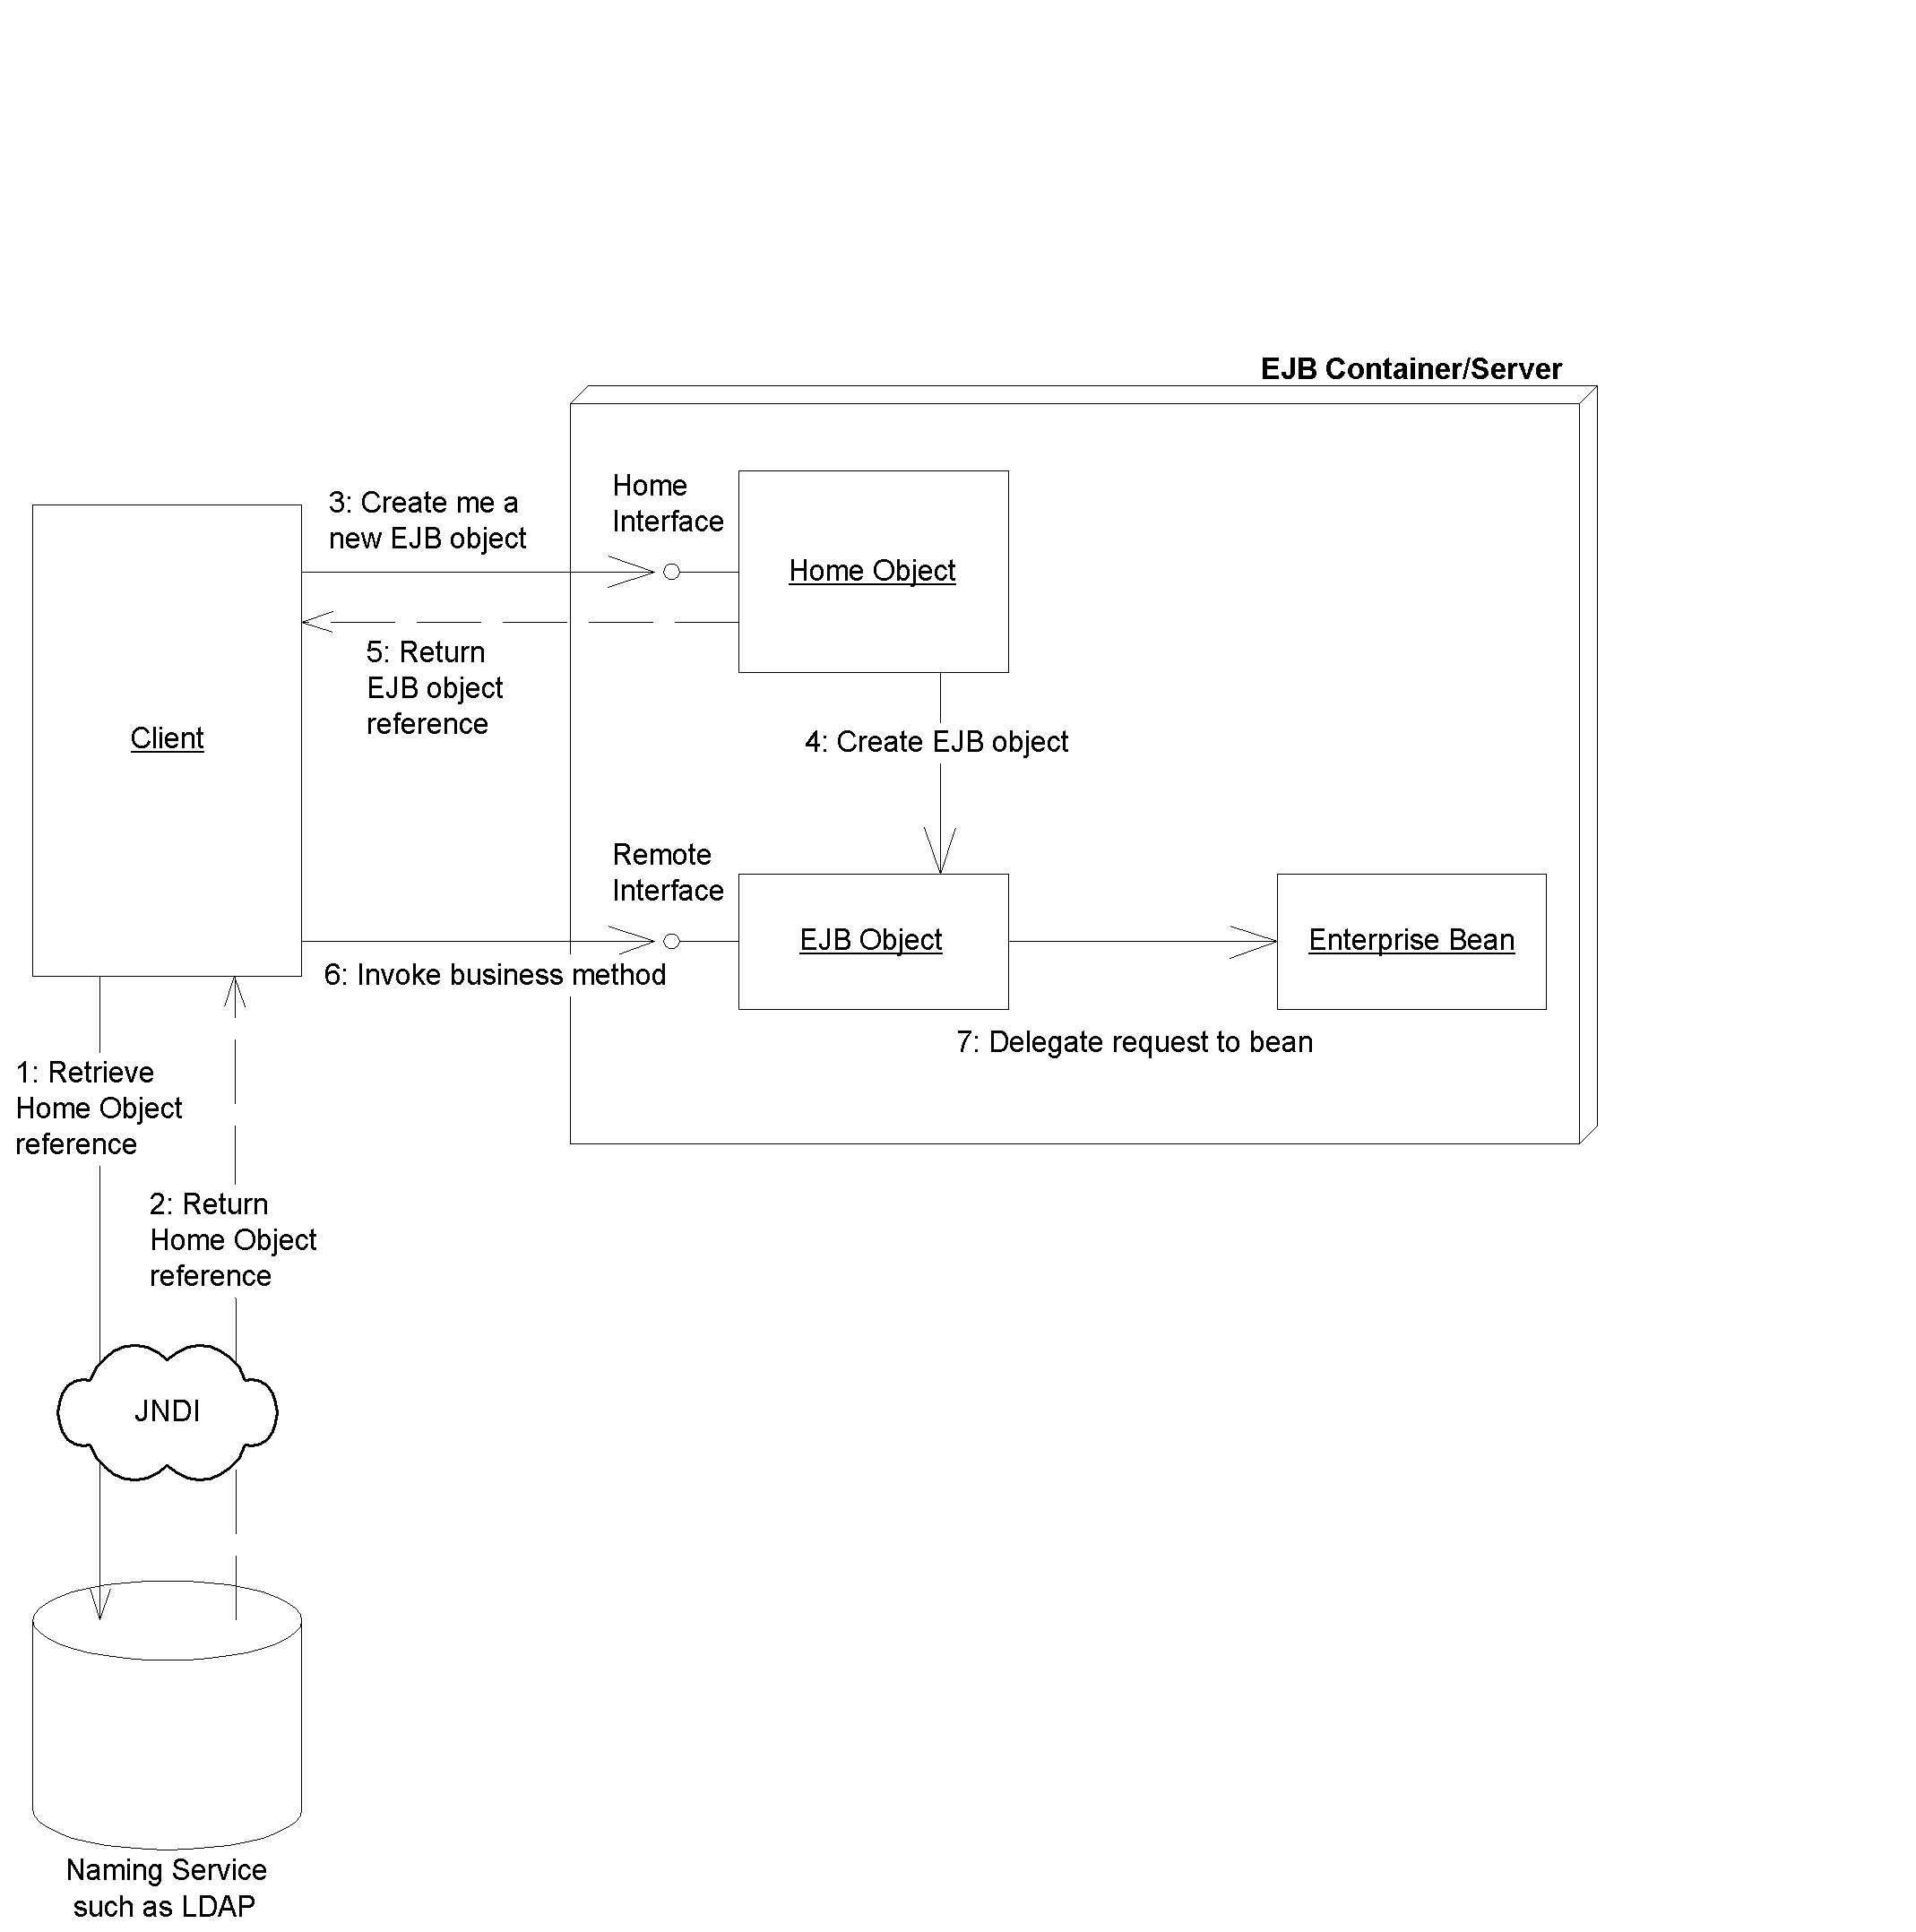Figure 2.X Acquiring a reference to a home object.
The complete client source code illustrating the previous steps is shown in Source 3.X.
package examples;

import javax.naming.Context;
import javax.naming.InitialContext;
import java.util.Properties;

/**
* This class is an example of client code which invokes
* methods on a simple stateless session bean.
*/
public class HelloClient {

public static void main(String[] args) throws Exception {
/*
* Setup properties for JNDI initialization.
*
* These properties will be read-in from
* the command-line.
*/
Properties props = System.getProperties();

/*
* Obtain the JNDI initial context.
*
* The initial context is a starting point for
* connecting to a JNDI tree. We choose our JNDI
* driver, the network location of the server, etc
* by passing in the environment properties.
*/
Context ctx = new InitialContext(props);

/*
* Get a reference to the home object - the
* factory for Hello EJB Objects
*/
Object obj = ctx.lookup("HelloHome");

/*
* Home objects are RMI-IIOP objects, and so
* they must be cast into RMI-IIOP objects
* using a special RMI-IIOP cast.
*
* See Appendix X for more details on this.
*/
HelloHome home = (HelloHome)
javax.rmi.PortableRemoteObject.narrow(
obj, HelloHome.class);

/*
* Use the factory to create the Hello EJB Object
*/
Hello hello = home.create();

/*
* Call the hello() method on the EJB object. The
* EJB object will delegate the call to the bean,
* receive the result, and return it to us.
*
* We then print the result to the screen.
*/
System.out.println(hello.hello());

/*
* Done with EJB Object, so remove it.
* The container will destroy the EJB object.
*/
hello.remove();
}
}
Source 3.X HelloClient.java .
The client code is self-explanatory.
Running the System
To try out the deployment, you first must bring up the application server. This step will vary depending on your vendor.
Next, run the client application. When running the client, you need to supply the client with JNDI environment information. As we explain in Appendix X, JNDI requires at a minimum two properties to retrieve an initial context:
- The name of the initial context factory. An example is com.sun.jndi.ldap.LdapCtxFactory.
- The provider URL, indicating the location of the JNDI tree to use. An example is ldap://louvre:389/o=Airius.com.
The actual parameters you need should be part of your EJB container’s documentation. See the book's accompanying source code for examples of this.
Note
For your EJB client code to work, you must take care to distribute the correct class files on the right machines. Because client code uses home interfaces and remote interfaces, you must deploy those class files in your client environment. And because clients never directly access your bean implementation, you don’t need to (nor should you) deploy your bean classes in your client environment.
The Server-Side Output
When we run the client, our container shows the following debug log (debug logs are great for seeing what your enterprise beans are doing):

setSessionContext()
ejbCreate()
hello()
ejbRemove()

As you can see, the container associated our bean with a session context, called create(), delegated a business method to the bean, and then called remove(). Note that some containers may give slightly different output than others--it’s all implementation-specific and part of EJB product differentiation. Keep this in mind when debugging your beans.
The Client-Side Output
After running the client, you should see the following output:

Hello, World!

Congratulations--it took awhile, but you’ve successfully completed your first Enterprise JavaBeans deployment!
Summary
In this chapter, we got up-to-speed on how to write a simple EJB component. Now that you've been through the development process of a single bean, you should be well prepared to move on to explore the details of each bean type in the coming chapters.

